

**Sabden and Whalley Medical Group**

**In this issue>>>**

* New recall system for chronic disease. - Pharmacy briefing.
* Carers Link - Easter opening hours.
* New Recruits. - Dr M Onrust’s retirement.
* Continuity of care. - Patient participation Group.



Easter Opening Hours

Thursday 28th March 2024 – OPEN AS USUAL

Friday 29th March 2024 – CLOSED

Monday 1st April 2024 – CLOSED

Tuesday 2nd April 2024 – OPEN AS USUAL

**Prescription requests**

Please be aware that the bank holiday closures may affect patients who have repeat medications. We would advise that you check your medication in advance to prevent you running out over the easter period.

We do advise that it can take up to 48 hours for your prescription request to be processed, however due to the increase in prescriptions being requested before a closure we ask you to allow 72 hours.

**Dr M Onrust’s retirement**

As most are now aware Dr M Onrust’s final working day before she retires will be Thursday 28th March 2024, although we are sad to see such a great Doctor leave our practice, we wish her all the best and a very happy retirement.

Message from Dr Onrust:

‘As I reflect on my journey since qualifying as a doctor in 1989, I am filled with gratitude for the incredible 34 years that have unfolded. From performing remote surgical work in Nepal to contributing to healthcare development (1992 - 2004), and later transitioning to General Practice in the UK, each chapter has brought its unique joys.

Embracing the continuity of care has added a special perspective on my career, and I’ve found immense fulfilment in the meaningful connections formed. Now, as I announce my retirement, I choose to continue making a difference through volunteering. While the specifics of my volunteering work are not yet defined, I am excited about the possibilities that lie ahead.

I extend my heartfelt thanks to all my patients for the trust you’ve placed in me. It has been an honour to serve you and I wish each of you well on your journeys.

With warm regards,

Dr Marjoleine Onrust

We would also like to take this opportunity to thank all the patients who have left kind messages in the retirement books which have been left at each surgery.

Find us on Facebook.

Find us online at www.whalleysurgery.nhs.uk

CONTACT US

Telephone – 01254 919888/Email – whalley.surgery@nhs.net



* Dr Bethany Hayden-Pawson – Salaried GP.
* Dr Adam Dedat – Salaried GP
* Dr Mohsin – ST2 (GP Trainee).
* Libby McGuiness – Treatment Room Nurse.
* Lyn O’Grady – Administrator.

PATIENT PARTICIPATION GROUP (PPG)

What is the Patient participation group?

The PPG is a group of patients who regularly have meetings throughout the year to discuss a wide range of topics involving the practice, such as premises updates, staff updates, changes and more.

Can I sign up to the PPG?

We welcome all patients to sign up to become a member of our PPG, you can do this by completing the sign-up form on our website and returning it to our Reception Team.

Website link - [Patient Participation Group - Sabden and Whalley Medical Group (whalleysurgery.nhs.uk)](https://www.whalleysurgery.nhs.uk/practice-information/patient-participation-group/)

What is the aim of the PPG?

* To Generate ideas to improve patient experience.
* To feedback suggestions for improvement.



**We are making changes to the way that we call in patients for their annual chronic disease reviews.**

From the 1st of April 2024 we will calling in patients for chronic disease annual reviews from their birth month.

Common questions:

Q. What if I have had my annual review with the last twelve-months?

A. You will still receive your annual invite, but it will be in your birth month, this may mean that your appointment this year may be slightly earlier or later than when it would normally be due.

Q. What if I have more than one chronic disease and usually have multiple appointments?

A. You will now be able to have multiple conditions reviewed at one appointment.

Q. Will I be able to book my reviews online?

A. Yes, you can still book your reviews online using the NHS App. If you receive your invite via text message this will also include a booking link which will direct, you to the most appropriate appointment.

# Continuity of care

We have been working on a project call continuity of care, which will allow us to look at areas such improving our patients experience by encouraging good continuity of care, whether this be for our safeguarding or palliative patient or those who need several reviews or follow ups.

You may have seen on our Facebook page that we published a questionnaire allowing patients to answer questions on if they feel we as a practice achieve good continuity of care. We have now gathered all these answers and are in the process of reviewing each answer.

We hope that be by completing this project it will improve our overall patient experience, free up much needed appointments and allow patients to build a trusting and better relationship which their clinician of choice.

**Pharmacy First Service**

A new advance pharmacy first programme has now been announced as part of the Primary Care Recovery Plan. This new service aims to improve access and help build better capacity with Primary Care.

Some minor illness symptom groups which can be referred to a community pharmacist for treatment include:

* Acne, spots, and pimples.
* Allergic reaction.
* Athlete’s foot.
* Insect bites and stings.
* Blisters.
* Coughs, colds and flu.
* Diarrhoea, constipation or rectal pain.
* Earache, ear discharge or ear max.
* Irritable or red eyes.
* Hair loss.
* Lower back pain.
* Mouth ulcers.
* Nasal congestion or sinusitis.
* Pain and/or frequency passing urine.
* Scabies.
* Scratches and grazes.
* Teething.
* Tiredness.
* Vaginal discharge, itching or soreness.
* Vomiting.

You will still need a formal referral from your GP through digital means for the any minor illness consultations with a pharmacist and once you have had your appointment with the pharmacist, the surgery will receive notification of any treatments you may have had.

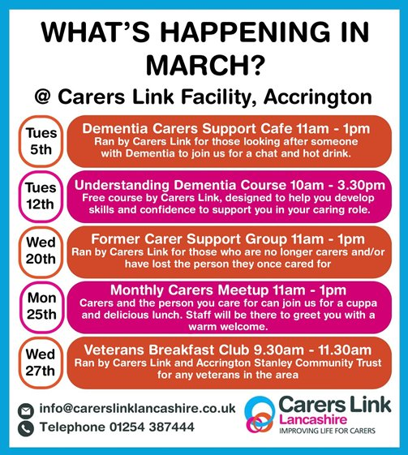

# Carers Link

As part of March’s protected learning time reception staff took part in training provided by Carers Link. During this training the receptionists learned about different types of carers and the variety of support which is available.

What is Carers Link?

Carers Link is a Lancashire based charity which aims to provide support to carers within Lancashire. The Charity was originally founded in April 1997 with the Lancashire branch opening in April 2014.

Carers Link’s mission

‘Our mission is to make a positive difference to the lives of carers and the people that they care for by offering tailored support that is professional, respectful, non-judgmental and meets individual needs’.

Facts

* According to the 2011 census, there are over 42,000 carers within East Lancashire.
* It is estimated that there are around 6.5 million carers within the UK (around 1 in 8 people).
* Three out of five people within the UK will become a carer at some point in their lifetime.
* It is estimated that carers save the UK economy £132 billion each year.

If you would like additional information, support or to register as a carer please use the link below to access the carers link website.

[Home | carers-link-01 (carerslinklancashire.co.uk)](https://www.carerslinklancashire.co.uk/)

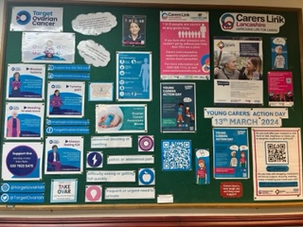

Whalley noticeboards

Your may have noticed that the Reception and Administration Team have been working on updating and improving our noticeboards at the surgery. The aim is to provide patients with up to date and relevant information to help improve the patient experience and raise awareness on a variety of different useful topic. We recently asked our PPG to vote for the best noticeboard and we can confirm that the winner was the Nutrition and Hydration Awareness display which was completed by Beth.